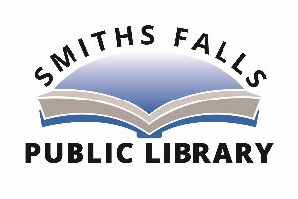

The Smiths Falls Public Library will be re-opening on Wednesday, July 22. We will resume our regular schedule (Mon. – Thurs. 1:00-8:00 p.m., Fri. 10:00-5:00 p.m. and Sat. 10:00-4:30 p.m.). In-library programming will not resume at this time and we will continue to offer virtual programming. There will be some changes to library service.

- Entry by front door only unless you require the accessible entrance
- Face mask required
- Hand sanitizer available when you enter the library
- Limit to the number of people in building to ensure physical distancing
- Limited number of public computers available. Bookings can be made by telephone or in person. Computers to be disinfected between appointments.
- Limited seating to ensure physical distancing
- Enhanced cleaning protocols
- Curbside pickup will continue two mornings a week

Our staff are looking forward to welcoming everyone back to the library.

For more information, contact the library at 613-283-2911.

