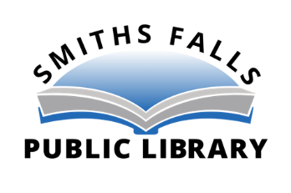

Services at the Smiths Falls Public Library will be reduced due to the provincial lockdown announced yesterday. In-person browsing and use of public computers and photocopiers will not permitted during the lockdown.

The library will be open on Dec. 22nd and 23rd from 1:00-8:00 p.m. and 1:00-3:00 p.m. on Dec. 24th.
Curbside pickup will be available starting Dec. 28th.
Requests for materials can be submitted in three ways:
- by the online catalogue https://smithsfalls.insigniails.com/Library/Home
- by email smithsfallslibrary@vianet.ca
- by telephone 613-283-2911

The book drop-off at the Elmsley St. entrance will remain open and materials can be returned at any time. All returns are quarantined for 72 hours and disinfected before returning to the shelves.
The health and safety of library users and staff is important to us. To keep us all safe, we will be following the most current health and safety guidelines throughout this process
For more information, contact the library at 613-283-2911.

For further information, please contact:
Karen Schecter
Chief Executive Officer
Smiths Falls Public Library
81 Beckwith St., North
Smiths Falls, ON
K7A 2B9
613-283-2911
kschecter@vianet.ca

